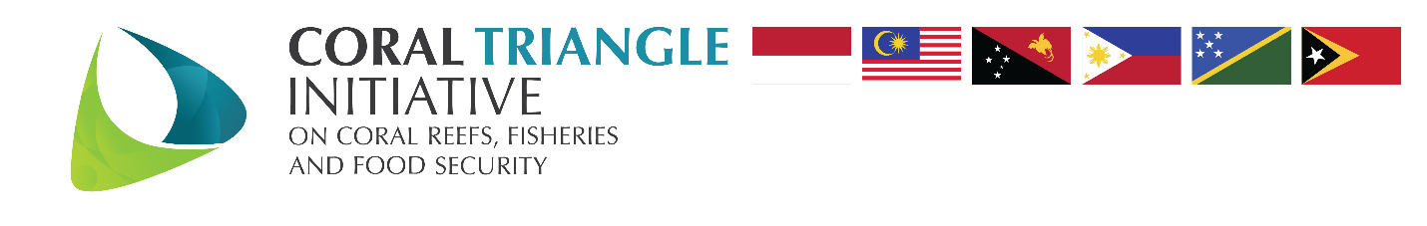

IMPLEMENTATION STRATEGY FOR
REGIONAL PLAN OF ACTION 2.0

Contents
INTRODUCTION 3
GOALS 2021 – 2030 3
GUIDING PRINCIPLES 3
GOVERNANCE AND OPERATIONAL CONSIDERATIONS 4
MONITORING AND EVALUATION 5
The M&E Plan Framework 6
Data Collection and Information Sharing and CT Atlas 8
Knowledge and Data Management System 9
CTI-CFF RELEVANCE TO GLOBAL TARGETS 9

INTRODUCTION
First endorsed in 2009, the 10-year RPOA provides the guiding framework for the Coral Triangle Initiative on CTI-CFF and has led to a wide range of accomplishments in the CTI region (i.e., marine region covering segments of the waters of the six member countries, comprising of Indonesia, Malaysia, Papua New Guinea, Philippines, Solomon Islands, and Timor-Leste).
CTI-CFF success in implementing previous 10-year Regional Plan of Action proves that this Initiative is important in improving the management of coral reef, fisheries and food security in the region. With more ambitious goals for the next 10 years, CTI CFF looks forward to ensuring coastal communities and coastal and marine ecosystems in the CT region are more resilient/able to adapt to impacts of climate change, natural and anthropogenic threats, by improving food security, sustainable fisheries and coastal livelihoods.
As the commitments in the RPOA 1.0 are implemented, the CT6 and partners anticipate achieving tangible and measurable improvements in the health of the CT marine and coastal ecosystems, status of the CT ﬁsheries, and in food security and well-being of the communities which depend on them. To further support such improvements, the RPOA 2.0 is developed to focus and align regional collaboration in support of outcomes that will be considered beneficial by the CT6 Countries in the next ten years for 2021 to 2030, with review in 2025 and is focused to allow for relevant, feasible, and measurable impacts.
This implementation strategy is to serve as a guideline for the implementation of CTI-CFF objectives and activities of the 10-year Regional Plan of Action goals of RPOA 2.0. Moreover, this document aims to help CTI-CFF perform its duties in facilitating regional collaboration around sustainable development policies and practices related to marine resource utilization.

GOALS 2021 – 2030
There are two goals of RPOA 2.0, these are:
- By 2025, coastal communities and coastal and marine ecosystems are enabled to cope with the impacts of climate change, natural and anthropogenic threats, in the Coral Triangle region, due to measurable increased regional collaboration between the CT6 and our partners, for the implementation of the RPOA 2.0 facilitated through a strong and effective CTI-CFF.
- By 2030, coastal communities and coastal and marine ecosystems in the CT region are more resilient/able to adapt to impacts of climate change, natural and anthropogenic threats, by improving food security, sustainable fisheries and coastal livelihoods.

GUIDING PRINCIPLES
The following components shall form part of all the program implementation be undertaken:
- CTI should be recognized as the main source of reference point for marine biodiversity conservation, sustainable development, poverty reduction and equitable beneﬁt sharing in the Coral Triangle Region.
- Implementation of RPOA 2.0 should be guided by the spirit of inclusive collaboration, partnership and multi-stakeholder engagement. Multiple stakeholder groups should be actively engaged in the implementation, including other national governments, local governments, NGOs, private sector companies, bilateral donor agencies, multilateral agencies, Person with Disability (PWDs), Indigenous People and local communities, coastal communities, including women and youth and the academic and research sectors.
- Implementation of RPOA 2.0 should be centered on concrete and quantitative goals with proper preparation, budgeting and documentation of activities.

GOVERNANCE AND OPERATIONAL CONSIDERATIONS
Successful implementation of the CTI-CFF Regional Plan of Action—with its wide-ranging and ambitious scope—requires well-structured and highly effective coordination mechanisms across different levels in the organizations (Figure 1). The CTI-CFF operates through core decision-making and implementing bodies, including the Council of Ministers (COM), Council of Senior Officers (CSO) and National Coordinating Committee (NCC), all of which are being facilitated by the Regional Secretariat (RS).
The COM is the highest formal decision-making body of the CTI-CFF which meets every two (2) years and has the authority to approve and adopt CTI-CFF resolutions during Ministerial Meetings (MM). The Chair position of CTI–COM rotates every two (2) years among member countries in alphabetical order by reference to the first letter of the countries’ names. The CSO is composed of designated senior government officials from the six (6) countries who are tasked to oversee and provide guidance on decisions of CTI-CFF and provide direction to the RS. The RS facilitates and coordinates activities to implement RPOA 2.0. and serve as the primary communication platform for all stakeholders. The role of RS can be changed depending on the performance, financial and system audit throughout its operation.
The NCC is the members of the organization representing each member country. It is represented by officials from different government agencies. In addition to this, NCC can form a Technical Working Group (TWG) with representatives composed of technical experts nominated by the six countries’ NCCs. TWGs should meet regularly and proactively lead the implementation and decision-making process on the prioritisation of CTI activities and implement communication and outreach activities with support from RS. Each working group is led by a Chair and Vice/Co-Chair and provides inputs and recommendations to SOM, NCC and RS.
Governance Working Groups (GWGs), Cross-Cutting Initiatives (CCIs) and Scientific Advisory Group (SAG) complement and actively support the TWGs in terms of providing inputs in the internal and external operations of RS, cross-cutting themes and scientific information to support CTI-CFF Implementation. Other country governments outside CT6, strategic partners and international organizations provide technical and scientific expertise as well as funding support in the implementation of activities.
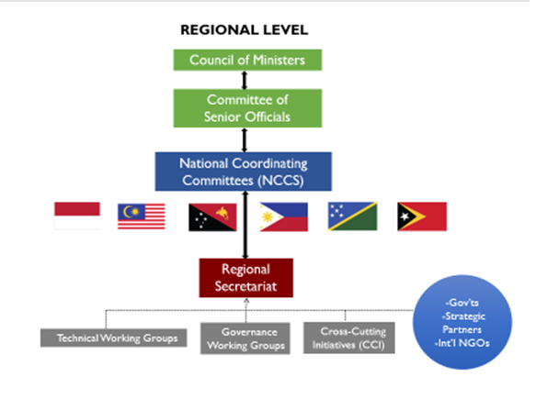
Figure 1. CTI-CFF Organizational Structure

MONITORING AND EVALUATION
Monitoring and evaluation (M&E) under the Coral Triangle Initiative on CTI-CFF is a vital component of adaptive project planning and management that is central to the attainment of the program’s goal of sustaining the flow of benefits from marine and coastal resources in the Coral Triangle region. It involves the regular, systematic, and timely monitoring, measurement, and evaluation of the results of program actions to improve effectiveness and efficiency of operations, use of resources, and delivery of benefits; ensure the relevance of interventions; enhance collaboration and accountability of actions; and share lessons as input to well-informed decision making. In essence, the goal of monitoring and evaluation (M&E) in the CTI-CFF is to provide reliable, quality, and strategic information to management and stakeholders on the performance and results of the program as input to planning, implementation, and information exchange as well as to optimize implementation and sustain impacts. Under the RPOA 2.0, monitoring and evaluation feeds into the communications and fundraising strategies of the program to promote and facilitate evidence-based learning, knowledge sharing, and fundraising activities within the CTI-CFF.
The strategy describes the approach of the CTI-CFF on M&E with the view of improving the existing system towards reliability, responsiveness, and sustainability. It utilizes the program’s principles and commitment to action as guide and builds on the RPOA 2.0 and strong foundation on cooperation, learning, and knowledge sharing.

The M&E Plan Framework
This RPOA 2.0 has 2 goals, 3 objectives, 7 Targets, 33 Regional Activities, 33 Outcomes, 90 Outputs
RPOA 2.0 has 2 Goals
Objective 3
Objective 2
Objective 1
Target A1
(Outcomes & Outputs with indicators)
Target A2
(Outcomes & Outputs with indicators)
3 Regional Activities
(Outcomes & Outputs with indicators)
3 Regional Activities
(Outcomes & Outputs with indicators)
1 Regional Activity
(Outcomes & Outputs with indicators)
2 Regional Activities
(Outcomes & Outputs with indicators)
2 Regional Activities
(Outcomes & Outputs with indicators)
1 Regional Activity
(Outcomes & Outputs with indicators)
5 Regional Activities
(Outcomes & Outputs with indicators)
Target A3
(Outcomes & Outputs with indicators)
Target B1
(Outcomes & Outputs with indicators)
Target B2
(Outcomes & Outputs with indicators)
Target B3
(Outcomes & Outputs with indicators)
Target C1
(Outcomes & Outputs with indicators)

Figure 2. Alignment of Regional plan of Action 2.0.
The M&E plan framework presents the following measurable Objectives, Targets, Regional Activities of the RPOA 2.0. This framework also includes indicators, M&E target to be achieved, data frequency, data flow, means of verification and reporting. Evaluating and tracking the activities undertaken by using various methods such as survey, testing, questionnaire, interview or focus group discussion. Reporting will be made to the Committee of Senior Officials and Council of Ministers at the conclusion of the plan.
RPOA 2.0 Objectives, Targets and Regional Activities
Objective A: By 2030, health of coastal and marine ecosystems, priority threatened species and fisheries in the Coral Triangle region are improved through effective management actions.
- Target A1: Coral Reefs, Mangroves and Seagrass Beds
- Regional Activity A1.1 Support and/or strengthen regional and national conservation and management actions of coastal and marine ecosystems (coral reefs, mangroves, and seagrass beds) in the Priority Seascapes and Coral Triangle Marine Protected Area System CTMPAS through strategic partnerships.
- Regional Activity A1.2 Develop and execute sustainable finance strategies, and other innovative financing models, to increase financial self-reliance, for the management of the coastal and marine ecosystems in Priority Seascapes and CTMPAS.
- Regional Activity A1.3 Mainstream Ecosystem based adaptation and mitigation approaches for CT6 members and partners under the CTI-CFF framework.

- TARGET A2 THREATENED SPECIES
- Regional Activity A2.1 Develop and implement strategies and initiatives for addressing waste management and marine pollution in the Coral Triangle region.
- Regional Activity A2.2 Effectively address and combat illegal wildlife trade, including increased regional collaboration and improved monitoring efforts, in the Coral Triangle region.
- Regional Activity A2.3 Establishing and managing effective migratory species (marine mammals, sea turtles, sharks and rays) corridors in the Coral Triangle region.
- TARGET A3 HEALTHY AND PRODUCTIVE FISHERIES
- Regional Activity A3.1 Build on existing sub-regional groupings and implement transboundary actions in support of addressing IUU fishing in the CT Region.

Objective B: By 2030, Risk resilience and socioeconomic conditions, in particular food security and coastal livelihoods, of communities living in the Coral Triangle region are improved.
- TARGET B1 FOOD SECURITY AND COASTAL LIVELIHOODS
- Regional Activity B1.1 Implementation of the COASTFISH regional framework for sustainable coastal fisheries and poverty reduction initiatives in achieving food security and improving coastal livelihoods.
- Regional Activity B1.2 Strengthen sustainable marine tourism and other related or allied livelihood enterprises in the Coral Triangle Region to improve the well-being of coastal communities.
- TARGET B2 GENDER EQUALITY AND SOCIAL INCLUSION
- Regional Activity B2.1 Implementation of Gender Equality and Social Inclusion (GESI) Policy.
- TARGET B3 CLIMATE-RESILIENT COMMUNITIES
- Regional Activity B3.1 Improve capacity in generating and reporting information on Climate Change risks.
- Regional Activity B3.2 Partnerships, Assessment and Implementation of Climate Change Adaptation for coastal environment and small-islands ecosystems.

Objective C: CTI-CFF Governance, Leadership and Partnership.
- TARGET C1 GOOD GOVERNANCE, EFFECTIVE LEADERSHIP AND PRODUCTIVE STRATEGIC PARTNERSHIPS ACHIEVED.
- Regional Activity C1.1 The CTI CFF governance mechanism is strengthened through the adoption and implementation of the RPOA 2.0.
- Regional Activity C1.2 Develop a priority regional score card and dashboard to evaluate the potential contribution of newly proposed priority actions and new partnerships towards CTI-CFF objectives and follow-up accordingly.
- Regional Activity C1.3 CTI-CFF Regional Secretariat to facilitate and monitor the implementation of the communication strategy to raise the CTI - CFF's profile at the regional and international levels.
- Regional Activity C1.4 Development of policy and science-based research studies that cuts across all the objectives A to C for decision-making on key regional/global issues that will have significant impacts on the CT Region's marine and coastal communities.
- Regional Activity C1.5 Strengthening the facilitation and coordination roles of the Regional Secretariat in the implementation of the RPOA 2.0.

Data Collection and Information Sharing and CT Atlas
Regional Secretariat (RS) will collect data from the contributor whether directly or through Working Groups (WG) or National Coordinating Committee (NCC) based on the approved the revised M&E Data Collection and Information Sharing Mechanism during SOM 16. RS receives data directly from the contributor, via the CT Atlas website, and the data will go through the process as describe in below figures. RS also receives data directly from the contributor, but not via the CT Atlas website, then the data will be verified by RS, and/or the WG/NCC.
After the validation, considering the RPOA 2.0/RPOA 1.0 /NPOA, the analyzed data/required information will be presented at SOM, if necessary. Based on the decision from SOM, the final product will be prepared for external sharing such as publication through CTI-CFF website and/or internal sharing such as distribution through emails. The final product includes reports, information management materials, policy recommendation, strategy, audio-visuals, etc.
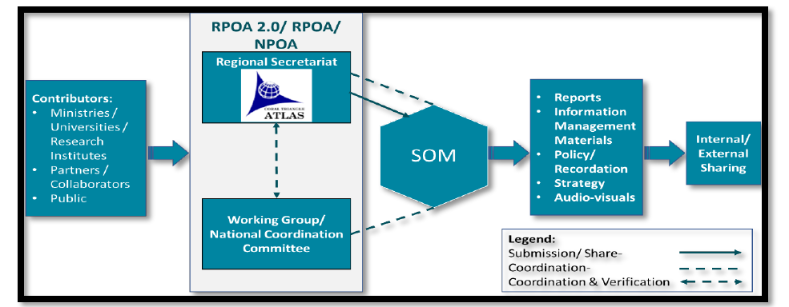
Figure 3. Data Collection and Information Sharing System

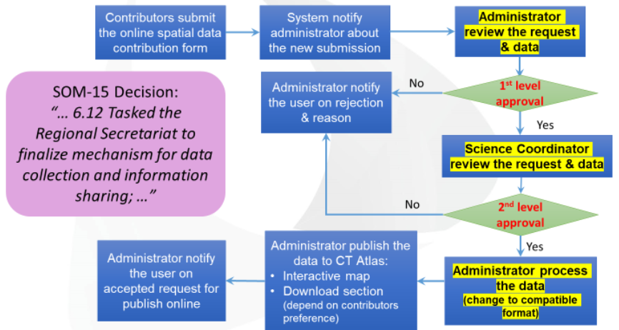
Figure 4. CT Atlas Data Collection Flowchart
RS receives data directly from the contributor, via the CT Atlas website, then it will go through the process as described below:
- Contributors submit the online spatial data/static map/publication/image data contribution form and must agree to the terms and conditions and license agreement.
- System will notify Administrator/IT Officer RS about the new submission, through an automatic email
- After 1st and 2nd level approval it will be published in the CT Atlas.

Knowledge and Data Management System
Effective information sharing and efficient decision-making on issues relating to the CTI-CFF RPOA can be achieved with an enhanced knowledge and data management system at the RS as well as NCCs. RS shall continue to maintain and manage the knowledge and data management system and ensure that all metadata are properly organized for easy accessing of information. A training for NCCs, Working Groups and CTI Partners will be implemented for effective converging and managing of information and supporting information sharing and communication activities.

CTI-CFF RELEVANCE TO GLOBAL TARGETS
CTI-CFF are increasing the efficiency and relevance of its goals and objectives by complementing existing Global Frameworks and Initiative such as:
UN Convention on Biological Diversity (CBD) where CTI-CFF contribute to one of its goal of ensuring that at least 30 per cent globally of land and sea areas, especially areas of particular importance for biodiversity and its contributions to people, are conserved through effectively and equitably managed, ecologically representative and well-connected systems of protected areas and other effective area based conservation measures, and integrated into the wider landscapes and seascapes in the CT Region within CTI-CFF Technical Working Groups.
UN 2015 Sustainable Development Goal (SDG), Goal 14 "Life below water" that aims to conserve and sustainably use the oceans, seas and marine resources for sustainable development by its work in protecting marine habitat, sustainable fisheries, marine sustainable tourism and climate change adaptation in small-Island within CT Region.
UN 2021 Climate Change Conference, COP-26 in Glasgow that agree to secure global net zero by mid-century and keep 1.5 degrees within reach, adapt to protect communities and natural habitats mobilize finance and work together as to tackle climate issues. CTI-CFF complement these goals with its work on Climate Change Adaptation Working Group (CCA-WG) and Trust Fund Development for independent and sustainable financing to support Fisheries and Marine Conservation.
Collaborative action of CTI-CFF with South Pacific Regional Environment Programme (SPREP), Association of Southeast Asian Nations ASEAN, Asia-Pacific Economic Cooperation (APEC), Coordinating Body on the Seas of East Asia (COBSEA) and its Regional Action Plan on Marine Litter (RAP MALI) and Experts WG on Marine Litter, United Nations Environment Programme (UNEP) Regional Seas programmes, the Global Programme of Action for the Protection of the Marine Environment from Land-Based Activities, and Sustainable Development Goals and Post-2030 Agenda, on marine plastic litter. Additionally, CTI-CFF is working with WWF’s plan to assist CTI-CFF in undertaking a Stocktake of marine plastics in the CT region.

